Ex no: 19

Date:

**PERFORMING SOME GIVEN COMMANDS**

**AIM:**

To create a table bank with the given details.

1. Creating table bank and inserting the given values:



1. To alter the table by adding a column salary:

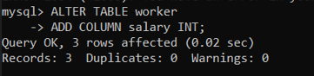

1. To alter the table by modifying any column name:

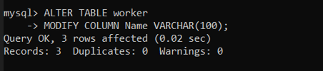

1. To show the table worker:

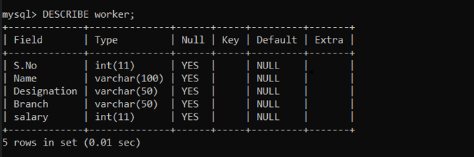

1. To copy the table worker as trainee:

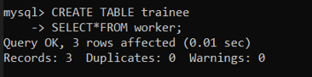

1. To delete the row from table:

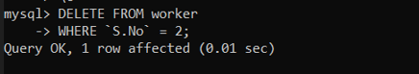

1. To drop the table:

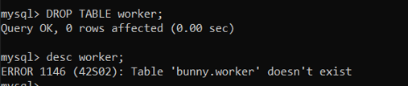

**Result:**

Given commands are performed and executed successfully.